Digital Item Catalog Viewer — Project Status Report

Executive Summary
I built a working Digital Item Catalog Viewer suitable for self‑checkout kiosks and store demos. The frontend delivers responsive, media‑rich browsing with search, categorization, pagination, and a simple cart/checkout flow. The backend exposes product data with server‑side pagination and a consolidated checkout endpoint. The system is verified with lint/build checks and is ready to demo to supermarkets and shops.

Objectives
- Present a visually engaging, responsive catalog for browsing products with images, descriptions, prices, and categories.
- Support kiosk workflows: quick add to cart, minimal friction checkout, idle attract overlay.
- Establish a backend API enabling scalable browsing (server‑side pagination) and consolidated checkout.

Deliverables
Frontend (React + Vite + TypeScript + Chakra UI v3)
- Search, category filters, and server‑side pagination for scalable catalogs.
- Product cards with images, category badge, and price; responsive, touch‑friendly UI.
- Item detail view with larger media and optional video.
- Cart and checkout posting a full cart payload to the backend; success banner with calculated total.
- Kiosk mode overlay: idle attract screen after inactivity, dismissible on touch/click.
Items Backend (FastAPI)
- Server‑side items pagination with query params for page, per_page, search, and category.
- Categories endpoint providing category list.
- Consolidated checkout endpoint accepting full cart payload and returning totals.
- CORS configured for local dev and static preview origins.

Key Features Implemented
- Interactive browsing: search and category chips, backend‑driven pagination.
- Multimedia: product images on list and detail views; optional video player.
- Responsive design: Chakra UI layouts optimized for kiosks and touch.
- Categorization: item categories and a categories API for filtering.
- Checkout flow: cart payload sent to backend; totals computed server‑side.

Architecture
- Frontend: React 19 + Vite 7, TypeScript 5.9, Chakra UI v3.
- Backend: FastAPI serving items, categories, item detail, submissions, and checkout.
- Optional services: Notify microservice scaffolded for future integrations.

Primary Endpoints
- GET /items?page=&per_page=&q=&category= → { items, total, page, per_page } (items-backend/main.py:46)
- GET /items/{id} → single item (items-backend/main.py:65)
- GET /categories → list of category names (items-backend/main.py:81)
- POST /checkout → accepts cart payload and returns total (items-backend/main.py:104)

Frontend Highlights
- Catalog page with category chips, images, prices, and server‑side pagination (catalog-frontend/src/pages/ItemsList.tsx:26).
- Product detail with larger media and optional video (catalog-frontend/src/pages/ItemDetail.tsx:58).
- Chakra provider and app shell (catalog-frontend/src/App.tsx:1).
- Kiosk attract overlay (catalog-frontend/src/components/KioskShell.tsx:1).
- API functions for items, categories, checkout (catalog-frontend/src/api.ts:1).

Quality Gates
- Linting: npm run lint passes.
- Build: npm run build succeeds and generates dist/.
- CORS updated to allow dev (5173) and preview (5174) origins.

How To Run
- Items backend: python -m uvicorn main:app --reload --port 8001 (c:/Work/ADG Intern/items-backend).
- Frontend dev: npm run dev → http://localhost:5173/ (c:/Work/ADG Intern/catalog-frontend).
- Frontend preview: npm run build && npx vite preview --port 5174 --host → http://localhost:5174/.

Demo Flow
- Open the catalog, use search and category chips to filter.
- Add items to cart, view total.
- Submit checkout; banner displays backend‑calculated total.

Decisions & Rationale
- Chakra UI v3 chosen for accessible and responsive kiosk UI.
- Server‑side pagination for performance and scalability.
- Consolidated checkout endpoint simplifies demo and integration.
- Idle attract overlay to match kiosk expectations and assist store‑floor demos.

Next Enhancements
- Department navigator (hierarchical categories with sidebar).
- Quantity selectors and per‑item modifiers on cards/detail.
- Image CDN optimization for faster thumbnails.
- Itemized receipts and order persistence (SQLite/Postgres).
- Kiosk features: full‑screen mode, attract slideshow, inactivity reset.

Screenshots
- Some snippets of our system, which I developed, as of now:

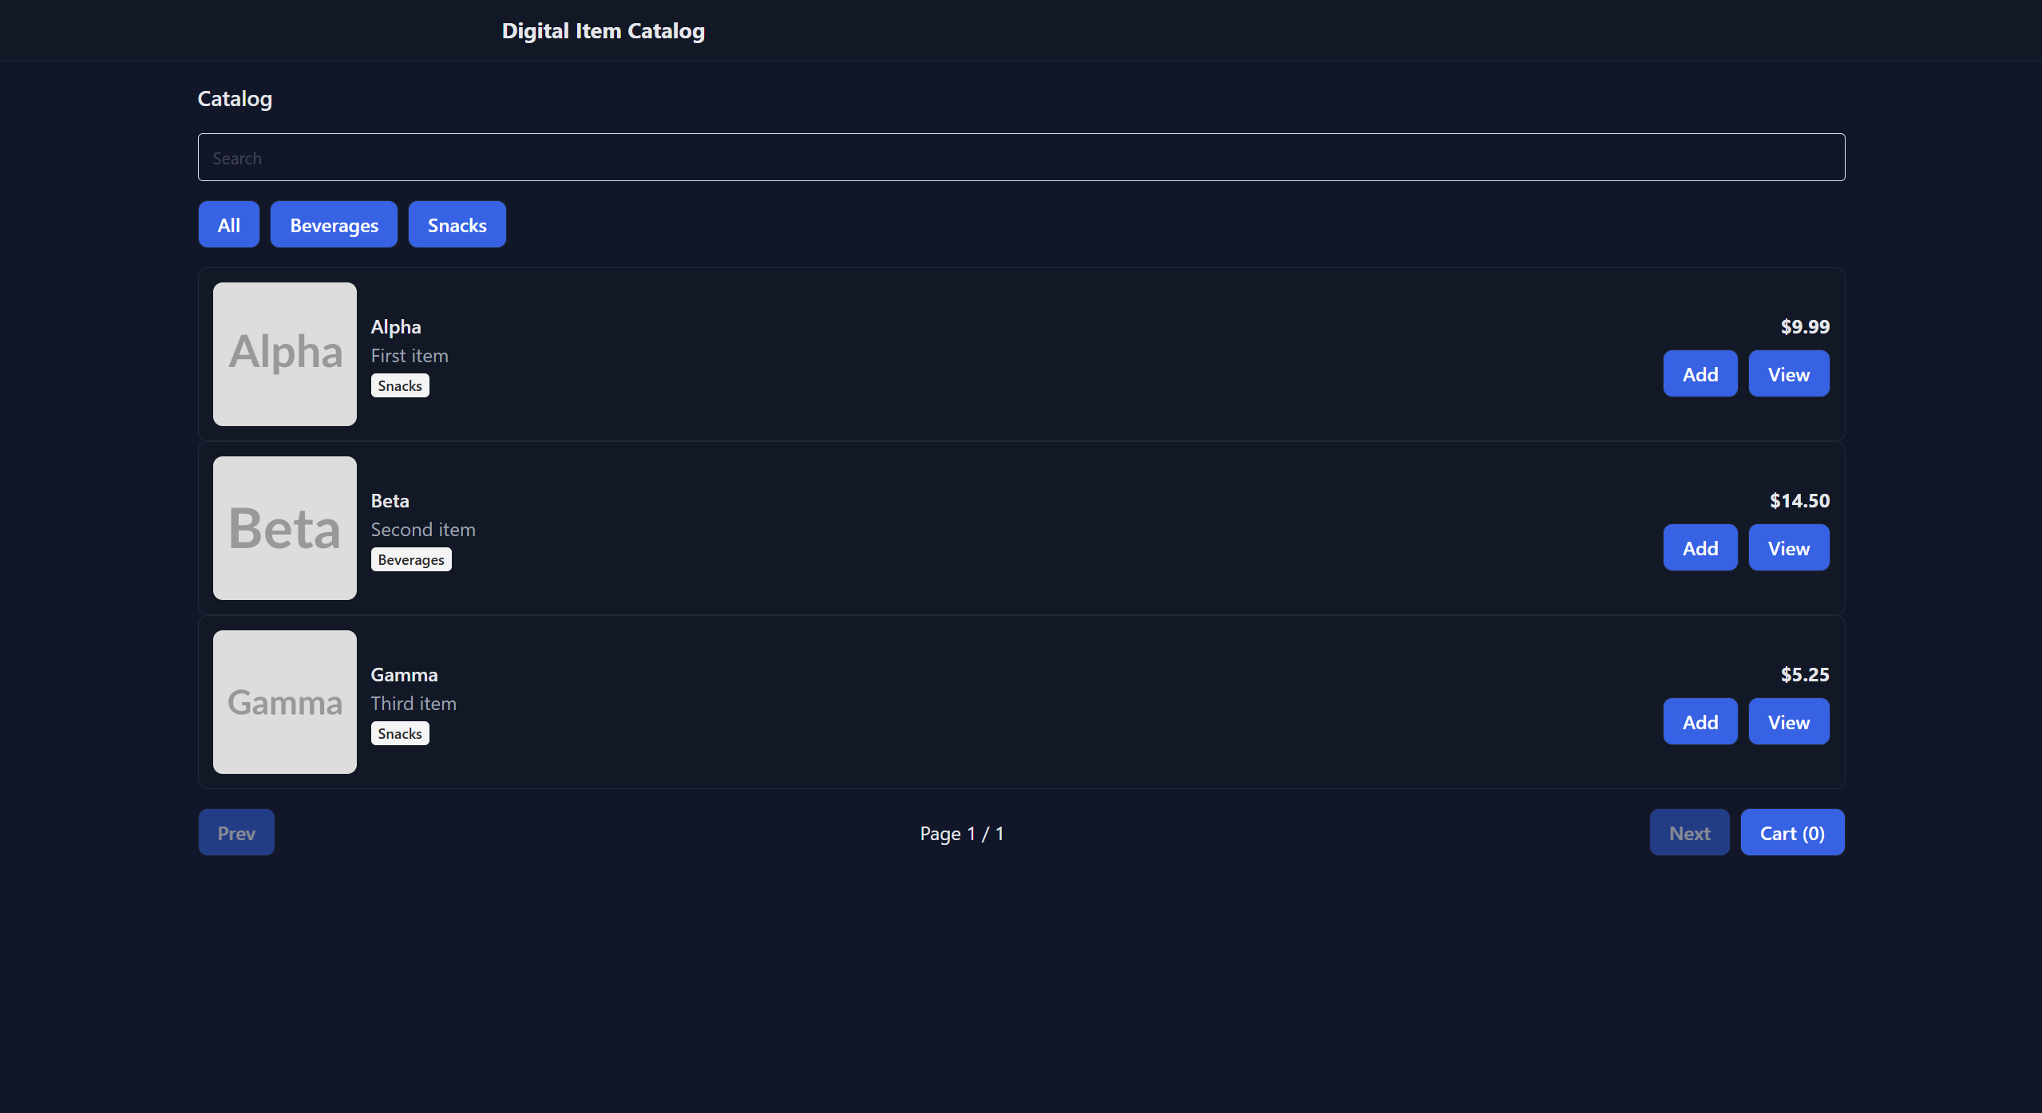
Fig 1: Main Interface
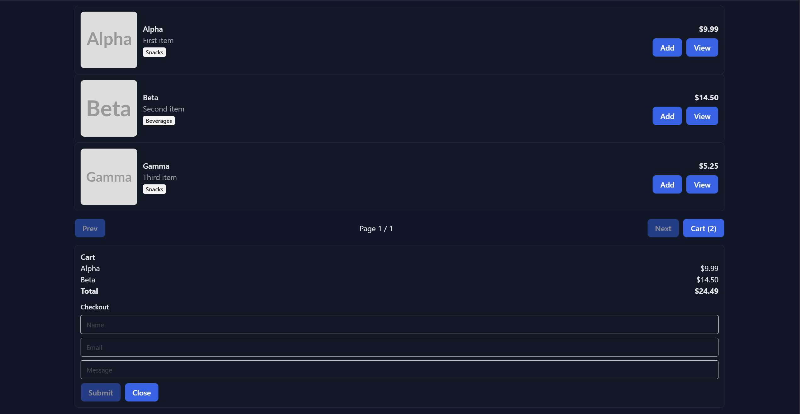
Fig 2: Cart Items (planning to create a separate page/section for the cart items in the future)

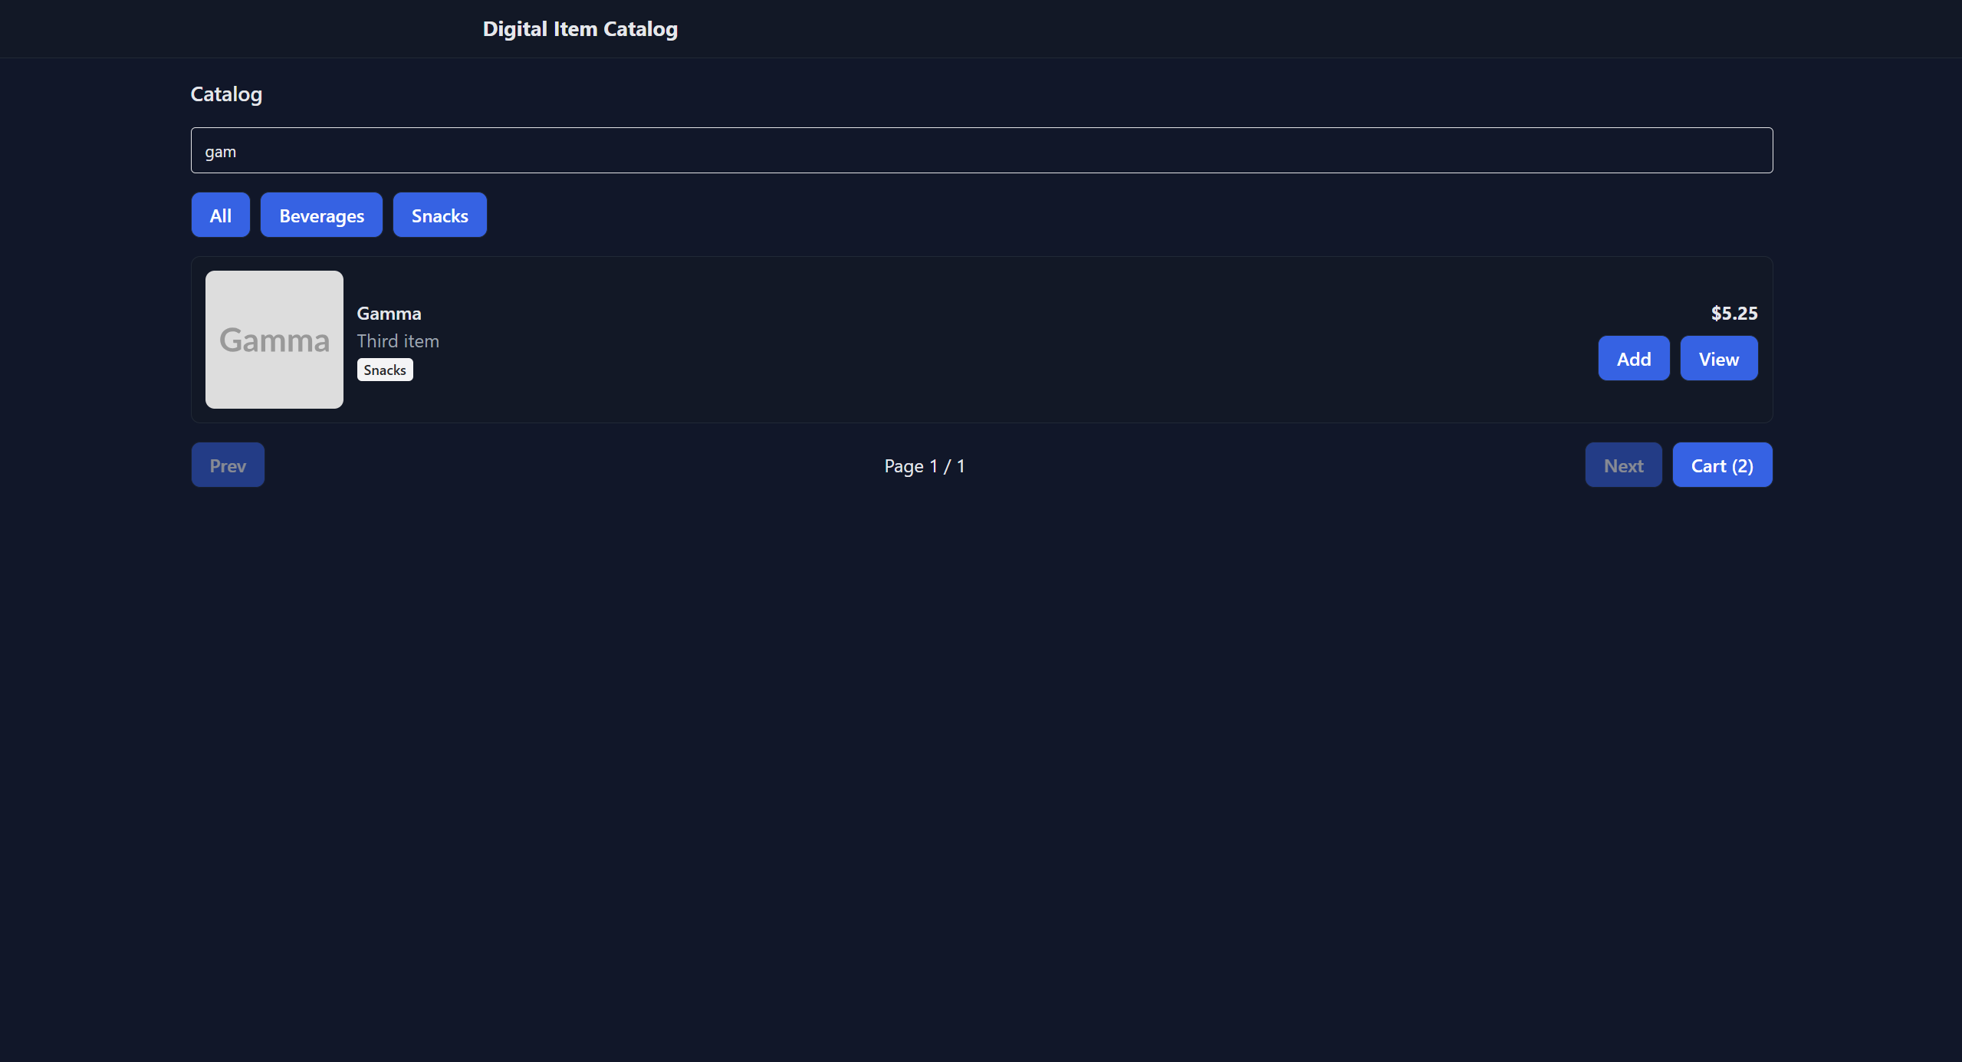
Fig 3: Seamless search

